Fox Hunt of 07-26-2008
By Dr. Peter Rock, KJ4ND
One of the Hounds

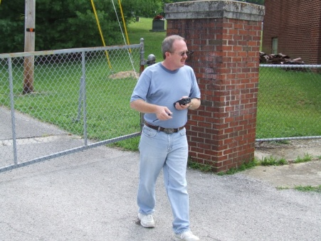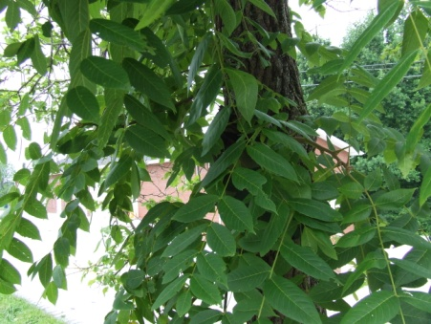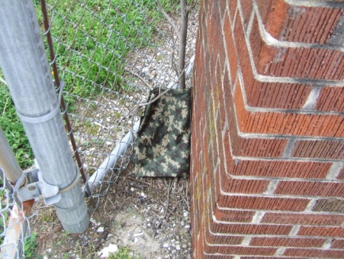

It had been a couple months since we had had a fox hunt, so I was looking foward to this one . The weather predictions were a little iffy with a 50% chance of rain .
About 9:30 I drove over to the meeting place near tractor supply . Since they have built the new Walgreen there , I had to shift over some in the parking lot area . Along the way I heard Leland KE4FGL and Dallas KI4VMP , who were both on their way for the fox hunt .
It was just a little before 10 am that Stan KD4ERF announced that the fox was on the air .
Soon after that the hounds arrived. None of us could hear the fox from that location. So I drove over to the hill behind Wal-Mart, and still could not hear it. We decided to try over by the library. I walked to the top of the hill by the library, and could just barely make out a signal above the noise level. It was approximately to the East. After some discussion, Dallas was going to head East on old rt. 80, and I would try to get another reading from Marvin's place (AG4RE).
Marvin wasn't home, but with my handheld beam, I barely got a reading again about to the East.
I called Dallas on the repeater, and let him know that it was still to the East, but barely detectable. So then I got back on the road, and headed East on rt. 80. I must have traveled at least 4 or 5 miles on rt. 80 before I heard it. Then it got louder very quickly, and at one point started to decrease again .So I turned around and onto that road. It was at the Bentley school area. Dallas was already there with his son, and Stan and Jim N4ICU.
We were told that there were 2 foxes to find (on the same freq.). I found the first one fairly quickly, but the second took a while. I think the second fox was not as strong as the first. But I did eventually find it on a tree by the road.
Leland arrived a little later, and after a short while he also found the foxes. So it was an interesting and challenging fox hunt. I am looking forward to the next one.

73's
Peter KJ4ND

